Gordonvale Primary School
PREP Transition Information

Child’s name: _________________________ D.O.B. __________________________

Preferred name: _____________Siblings at Gordonvale Primary: _________________

______________________________________________________________________

Parents Names: _________________________________________________________

SOCIAL EXPERIENCE:

Does your child prefer to play alone or with others? ____________________________

How does your child usually get along with other children?_______________________

______________________________________________________________________

Does your child play well by themselves or do they need adult supervision when playing?

Is your child independent in self-help skills - toileting
- dressing
- eating
- Looking after belongings

Does your child have any special needs/concerns? ________________________________________________________________________

________________________________________________________________________

How does your child usually react to changes? __________________________________

How would you describe your child’s language ability? ___________________________

________________________________________________________________________

Do you have any concerns about your child’s speech development? _________________

________________________________________________________________________

Are there any family circumstances that the Prep Teacher needs to be aware of? (For example, Custody issues) __________________________________________________

________________________________________________________________________

_____________________________________________________________________________________________________

What hand does your child prefer to use at home? Left Right Undecided

Medical History
Prenatal Concerns | Y N | Head Injury | Y N
Birth Concerns | Y N | Frequent Colds | Y N
Post Natal Concerns | Y N | Frequent Ear Infections | Y N
Vision Concerns | Y N | Febrile Convulsions (if under 7 yrs) | Y N
Hearing Concerns | Y N | Epilepsy | Y N
Allergies | Y N | Diabetes | Y N
Asthma | Y N | Stomach Complaints | Y N
Headaches | Y N | Knocked Unconscious | Y N

Please include copies of any specialist reports related to the above

Has your child attended any Child Care/Kindergarten Facility? 2016 Y/N 2017 Y/N

Please let us know what programs your child attended and when they started and finished. Refer to the list of Facilities/Centres attached for the names of the centres.

Centre name | Community Kids Gordonvale
Start date (month) | January, 2017  Example
Finish date (month) | November 2017
Hours per week | 12

Centre name
Start date (month)
Finish date (month)
Hours per week

Thankyou for sharing this information with us.

Cairns / Gordonvale Early Learning Centres and Programs.

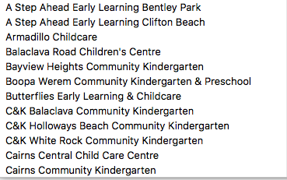  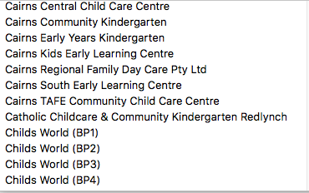  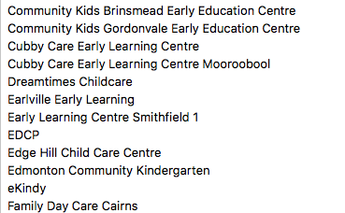  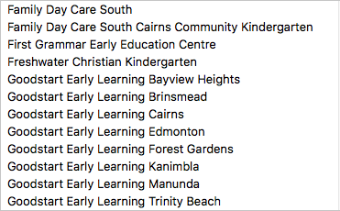 | 